**BUSINESS REQUIREMENTS DOCUMENT (BRD)**

**Dedicated Website for Paradise Light Homes LTD**

Version: 1.0

**Prepared by:** Iyanuoluwa Joseph Akinnusi, MBA, CPM, CHRP, ACIHRM, SFC, SSYBP

**Date:** Friday 25th of April, 2025

1. **DOCUMENT OVERVIEW**

**Purpose**

The purpose of this BRD is to define the business requirements for the dedicated website for Paradise Light Homes LTD. This document outlines the project objectives, scope, functional and non-functional requirements, and acceptance criteria. It is intended for the web development team, project managers, and stakeholders to ensure a clear direction and alignment on deliverables.

**Audience**

* Web Development Team
* Project Managers
* Marketing Team
* Business Stakeholders (including executive leadership and investors)

1. **BUSINESS OBJECTIVES**

**Primary Objectives**

* Establish a dedicated, professional online presence for Paradise Light Homes LTD.
* Showcase the company’s portfolio—including past success (Palm Villa 1), current projects (Palm Villa 2), and future Residential Estates.
* Drive lead generation and investor engagement through clear calls-to-action.
* Reinforce brand credibility, ensuring prospective customers and stakeholders understand the company’s core values (quality, innovation, sustainability, and community).

**Secondary Objectives**

* Support online marketing campaigns (digital ads, SEO, email marketing) by providing relevant project information and capturing leads.
* Provide an intuitive, user-friendly interface for visitors to access project details, contact information, and investor resources.
* Integrate content marketing features (blog/news, testimonials, case studies) to bolster SEO and thought leadership.

1. **PROJECT SCOPE**

**In-Scope**

* Development of a dedicated website with a custom domain (www.paradiselighthomes.com).
* Key pages:
  + Home
  + About Us
  + Our Projects (with sections for Palm Villa 1, Palm Villa 2, and future Residential Estates)
  + Investor Resources (FAQs, downloadable prospectus, documentation requirement details, ROI Calculator)
  + Blog/News
  + Contact Us (with forms integrated into CRM)
  + Testimonials/Case Studies
* Integration with social media channels and analytics tools.
* Responsive design ensuring compatibility across desktop, tablet, and mobile devices.
* Search Engine Optimization (SEO) best practices in coding and content structure.

**Out-of-Scope**

* E-commerce functionality (unless future iterations require an online payment platform).
* Custom mobile applications (focus is on a responsive web design).

1. **STAKEHOLDERS**

* Executive Leadership, Paradise Light Homes LTD
* Marketing Team
* Sales Team
* Business Development Team
* Web Development Team (Developer, Designer, QA)
* External Partners and Consultants (if any)

1. **FUNCTIONAL REQUIREMENTS**

**Website Pages & Structure**

* **Home Page:** 
  + Welcome banner with high-quality visuals of oil palm plantations and project imagery.
  + Brief value proposition and key calls-to-action (e.g., “Learn More,” “Reserve Your Plot”).
  + Navigation menu with links to main sections.

* **About Us:** 
  + Company history, mission, vision, and core values.
  + Details on the team and strategic partnerships.

* **Our Projects:** 
  + Dedicated sub-pages for:
    - Palm Villa 1 at Odeda LGA, Ogun State Nigeria (Past Success)
    - Palm Villa 2 (Current Acquisition – 2000 acres)
    - Future Residential Estates
  + Each sub-page should feature site plans, photo galleries, project details, and investment highlights.

* **Investor Resources:** 
  + FAQs, downloadable documents (e.g., Deed of Assignment, Survey Plan, Allocation Letter).
  + Investor prospectus and detailed project content.
  + ROI Calculator to calculate expected output (litres of Palm Oil produced) based on input (plots, acres or hectares acquired). Use of metrics rather than figures due to price instability. However, tentative figures can be generated based on investor’s input.

* **Blog/News:** 
  + Regularly updated posts featuring project updates, market insights, and company announcements.

* **Contact Us:** 
  + Interactive form that captures name, email, phone number, and inquiry details.
  + Maps and address details, along with phone numbers and emails.

**Key Functionalities**

* **Lead Capture:** 
  + Forms integrated with CRM for capturing investor inquiries.
  + Clear CTAs on every page.
* **Search Functionality:** 
  + Internal site search for users to quickly find information.
* **Content Management System (CMS):** 
  + Able to update pages easily (articles, images, videos).
* **Integration:** 
  + Social media feeds or links (Facebook, LinkedIn, Instagram).
  + Analytics tools (Google Analytics, similar).
* **Responsive Design:** 
  + Ensure the website displays well on multiple devices.
* **Security:** 
  + Secure hosting and HTTPS.
  + Data protection for lead capture forms.

1. **NON-FUNCTIONAL REQUIREMENTS**

* **Performance**
  + Website load time should be under 3 seconds on standard broadband connections.
  + Scalable to handle high traffic during marketing campaigns.
* **Usability**
  + Intuitive navigation and clear information architecture.
* **Reliability**
  + 99.9% uptime guarantee.
  + Regular backups and contingency measures.
* **Maintainability**
  + Use of a popular CMS (e.g., WordPress, Drupal, etc.) that allows non-technical staff to update content.
  + Documentation for all custom code and integrations.

1. **TECHNICAL REQUIREMENTS**

* Hosting: Secure, scalable hosting environment (cloud-based preferred).
* Domain: Registered and managed by the company.
* Development Framework: Open for discussion; focus on reliability, security, and modern web standards.
* Browser Compatibility: Support for current versions of Chrome, Firefox, Edge, and Safari.
* SEO Optimization: URL structure, meta tags, schema markup, and keyword-targeted content.

1. **ASSUMPTIONS & DEPENDENCIES**

* Assumption: Content (texts, images, videos, documents) will be provided by the marketing and content teams.
* Dependency: Timely coordination with the marketing team and stakeholder feedback for iterative reviews.
* Assumption: Funding is secured for all phases, including design, development, testing, and launch.
* Dependency: Third-party integrations (CRM, analytics) will be available and compatible with the chosen CMS.

1. **ACCEPTANCE CRITERIA**

* All listed pages and functionalities are delivered and integrated.
* The website passes usability and performance tests.
* Mobile responsiveness and cross-browser compatibility are confirmed.
* Security and data protection measures are in place.
* Stakeholder approval is obtained after user acceptance testing (UAT).

1. **TIMELINE & MILESTONES**

* Requirements Finalization:
* Wireframe & Design Approval:
* Development Start:
* Internal Testing & QA:
* User Acceptance Testing (UAT):
* Launch:

1. **RISKS & MITIGATION**

| **Risk** | **Mitigation** |
| --- | --- |
| Delays in content delivery. | Establish a content schedule and designate team leads. |
| Technical challenges with integrations. | Early testing and contingency planning with vendors. |
| Budget overruns due to scope changes. | Regular budget reviews and change request protocols. |

1. **APPENDICES**

* Find Requirements Traceability Matrix [here](https://docs.google.com/spreadsheets/d/1KrHYOzx0QlAeGlbC0WYSXS5ktabAKAvb/edit?usp=drivesdk&ouid=112949638973289826641&rtpof=true&sd=true) (it was too wide to fit into this A4-sized document either in Portrait or Landscape)
* Rough Visualization of Site

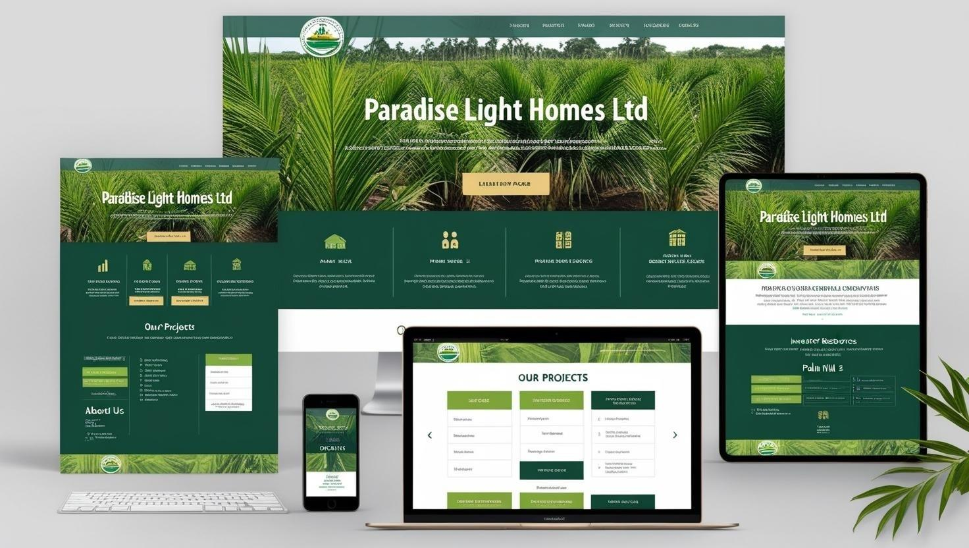

* Key Stakeholders Signature of approval

| Position | Name | Email | Signature |
| --- | --- | --- | --- |
| Chief. Executive Officer | Mr. Adegbamigbe Akinwale Eric |  |  |
| Business Analyst | Mr. Iyanuoluwa Joseph Akinnusi | iyanuoluwaajoseph@gmail.com |  |
| Web Developer |  |  |  |
| Project and Operations Manager |  |  |  |